Proposal for Youth Jobs in Fountain Park

Empowering At-Risk Youth Through the Elevation Young Entrepreneurs (EYE) Franchise Operations Training Program

Submitted To
City of St. Louis Department of Public Safety
Office of Violence Prevention

Submitted By
Collective Work Foundation
4901 Delmar Blvd.
St. Louis, MO
Steve Conley
Director of Global Community Initiatives
sconley@wecareworldwide.com
(314) 337 - 8468

Submission Date
November 16, 2024

Table of Contents

A. Cover Letter ............................................................................................................................ 2
B. Exhibit A — Program Narrative........................................................................................ 3 - 14
Attached Documents .............................................................................................. 15 - 31
Attachment 1 — Letters of References ........................................................15 - 17
Attachment 2 —Resumes/Qualifications....................................................`18
Attachment 3 — Organizational Chart ........................................................19
Attachment 4 — EYE Curriculum Snapshot ...............................................20 - 24
Attachment 5 — Memorandum of Agreement ........................................... 25 - 26
Attachment 6 — Budget for Year 1 of the EYE Program ...........................27
Attachment 7 — Letter Concerning Financial Status .................................28
C. Verification of License/Taxes ....................................................................................... 29 - 30
D. Minority & Women Business Enterprises (M/WBE)................................................. 31
*The St. Louis Living Wage Ordinance _Notarized Affidavit: Appendix 2 - 4 is attached to the email of our proposal submission.

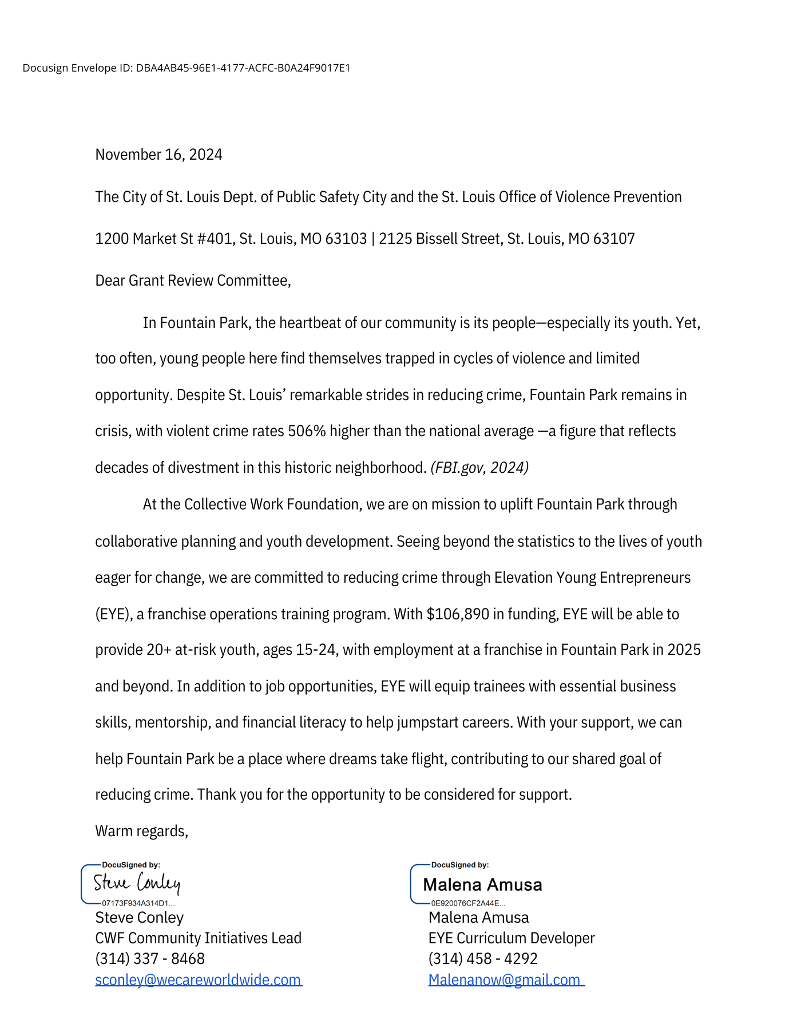

Exhibit A — Program Narrative

A Strong Record of Successful Service Delivery (1)
Our Mission and Background
The Collective Work Foundation (CWF), founded in 2017, is a 501(c)(3) organization dedicated to combating urban blight and revitalizing communities through collective economic and youth development. Based in Fountain Park at 4901 Delmar Blvd, St. Louis, MO, along the historic Delmar Divide, CWF was established by a group of concerned professionals committed to uplifting the neighborhood. Our team is made up of four visionary leaders: Joyce Coleman, Executive Director; Steven Conley, Director of Global Community Initiatives; Darren Miller, Franchise Manager and Outreach Coordinator; and Malena Amusa, Curriculum Developer —all of whom have decades of experience serving youth and communities in need. Since its inception, CWF has engaged residents and business leaders in Fountain Park through collaborative meetings and strategy sessions, building critical momentum and consensus for the EYE program.
CWF Leverages Extensive Experience to Provide Innovative Programming. At the heart of the Collective Work Foundation (CWF) are passionate, experienced servants who have helped thousands of young people find their path and contribute positively to their environments. Executive Director Joyce Coleman, along with our talented and diverse group of community and curriculum developers, bring a wealth of experience in youth empowerment and entrepreneurship, making CFW uniquely qualified to launch, implement and maximize the positive outcomes of the Elevation Young Entrepreneurs (EYE) Franchise Operations Training Program.
Through prior initiatives such as Coleman’s STEM Digital Village, Conley’s Young CEOs Program, Franchise Manager Darren Miller’s 25+ years of business and youth mentorship, and Malena Amusa’s 15+ years of providing arts education in St. Louis, our team has had the privilege of working with countless at-risk young people, transforming dysfunction into positive self-discovery and self-cultivation. These programs have been transformative for many participants, offering life-changing skill development and mentorship, empowering young people to acquire technical job skills, launch their own businesses, and stay on track toward their long-term goals.
Our Unique Strength is Local Engagement. One of our greatest strengths is our active engagement with local residents and businesses in Fountain Park. Notably, we are collaborating with Fountain Park’s cornerstone business development, the Elevation Coworking Space, set to officially open in March 2025. Our proposed program will partner with Elevation and the franchises within the space, working with Franchise Manager Darren Miller to provide at-risk youth with on-the-job training and mentorship. Additionally, we have secured commitments from Elevation Coworking Space owners to help fund the second year of the EYE program and to create a pipeline of jobs for participants interested in continuing careers in franchise operations. Over the past two years, we have generated significant excitement and built multi-sector consensus around launching this program, which now stands as a critical step toward achieving radical neighborhood stabilization and crime reduction in Fountain Park.
Another key strength is our collective 60+ years of experience working with high-risk African American youth in St. Louis City and developing people-centered solutions to prevent criminal behavior. This includes Joyce Coleman’s expertise in effectively communicating technical career topics to our target population online; Darren Miller’s role as a ‘credible messenger’ and motivational job trainer for youth across St. Louis; Steven Conley’s expertise in urban and personal wellness; and Malena Amusa’s track record of delivering in-community education that fosters peaceful exchange through the arts. Together, we bring a proven and innovative array of expertise, enabling us to deliver culturally resonant and impactful programming that drives long-lasting, meaningful results.
To further illustrate our capacity to scale this program, we’ve included the three key references in Attachment 1.

A Commitment to Applying an Equity-Centered Lens (2)
As a team, we are committed to integrating equity into every phase of strategic planning and implementation. CWF’s core approach focuses on meeting individuals where they are, celebrating their unique humanity, and equipping young people with the skills they need to excel. This equity-centered approach is reflected in our engagement with youth, families, business leaders, service providers, and city officials from diverse backgrounds. We believe that fostering connection and understanding, despite differences, creates a stronger, more positive community.
Attachment 2 includes our resumes and bios, while Attachment 3 provides an organizational chart detailing the staff committed to delivering the EYE program at the highest and most equitable level.
Guidance & Training is at the Core of Staff Support. A key benefit of working with CWF is our organization’s supervisory structure. It is designed to ensure support and guidance, especially for future staff who work directly with high-risk youth. Steve Conley, the Director of Global Community Initiatives, will serve as the program’s main champion, advancing community buy-in and partnerships, while supporting staff through positive and productive meetings and hands-on coaching.
Most importantly, to ensure our staff has the appropriate training required to effectively recruit at-risk young people, we are earmarking a portion of potential funds to receive best-in-class training in trauma-informed practices, if not provided already by OVP as a part of this proposal to help address the complex needs of both participants and staff.
Furthermore, we deeply recognize the impact of working in environments with exposure to violence and trauma, and continue to liaison with mental health support agencies that will provide all staff with access to counseling services and wellness resources. In times of public access, our primary operation will be at the Elevation Coworking Space, centrally located within Fountain Park and accessible by public transportation.

Proposed Programming/ Services (3)
Scope of Work
The Elevation Young Entrepreneurs (EYE) Franchise Operations Training Program, located at the Elevation Coworking Space in Fountain Park, will provide workforce and entrepreneurial skills training to high-risk youth, ages 15-24, from Fountain Park and surrounding areas, through hands-on experience and structured learning. Our program spans five core components: 1) Job Training Opportunities, 2) Job Readiness and Financial Literacy, 3) Supportive Services, 4) Mentoring, and 5) an Innovative Approach to Helping Youth Obtain Employment. By doing so, we are creating a groundbreaking, dedicated space for youth employment and economic development in Fountain Park—an opportunity that has never existed here before.
EYE is organized in three-month cohorts, with a new group of 5-10 participants onboarding each quarter. Participants will work daily shifts, Monday through Friday, as paid employees of two franchise locations within the Elevation Coworking Space: Auntie Anne’s Pretzels/Jamba Juice and PostNet. Each day, participants will receive 35 minutes of 1:1 and group mentoring and coaching from Franchise Manager Darren Miller, totaling 360-480 hours of on-the-job training. On Saturdays, participants will dive into project-based, skill-building workshops led by local business leaders, covering financial literacy, personal and business budgeting, franchise ownership, entrepreneurial skills, and personal development. To ensure program efficacy, EYE will actively steward our network of outside agencies to refer participants to resources that help remove barriers to work performance or program completion. As a full-spectrum employment solution, EYE also aims to build a network of collaborating franchises to assist participants in securing full-time employment at a St. Louis franchise by the end of the program. In fact, ensuring each cohort secures full-time employment by the program completion is our program’s primary benchmark and success measure.
Toward this goal, we are currently developing the program’s innovative 'employee-preneur' curriculum, which will be integrated into the mentoring sessions, on-the-job training, and Saturday workshops. This curriculum will allow participants to not only excel at working at a franchise but equip them with the skills to one day own a franchise, or establish a business in a related sector, including real-estate, marketing, and supply chain management. A preview of EYE’s key phases and curriculum is available in Attachment 4.
As a result of these comprehensive efforts, we aim to achieve transformative outcomes for at-risk youth in and around the Fountain Park community. The following are the projected outcomes of the EYE program:
- An Employment Hub in Fountain Park: Establishing a vital space in Fountain Park for at-risk youth to gain job experience and entrepreneurial skills—something the community has long needed. Empowering participants to be job takers and job makers by helping them to build life, job, and business skills, confidence, and self-awareness to overcome challenges.
- Enhanced Mentoring and Wrap-Around Support: Daily mentoring and coaching will guide youth in resilience and problem-solving, while our support network of service providers will help remove barriers to success.
- Innovative Curriculum: The employee-preneur curriculum equips young people with essential tools, including a comprehensive resume and portfolio, personal business plan, and financial management skills, empowering them to take charge of their futures.
- Job Readiness and Employment Pathways: In collaboration with franchise partners, CWF ensures that every cohort secures full-time employment upon completion of the program, helping participants transition from training to sustainable careers.
Underlying Values and Theories That Inform Our Program Design. EYE is founded on the principles of economic empowerment, skill development, and wrap-around support and mentorship. In the process, this program adopts an asset-based approach that emphasizes each participant’s unique strengths, encouraging self-efficacy through hands-on experience, nurturing, and collaboration. Culturally-responsive and project-based learning embedded in the program’s curriculum is central, allowing participants to solve real-world business challenges that are meaningful to them while developing personal and professional experience essential for long-term career success. Underpinning all of this is CWF’s belief in the Kwanzaa principle of Ujima that encourages each of us to work together to make things better for everyone.
Target Demographics and Recruitment Strategy. EYE targets high-risk, African-American youth ages 15-24 from Fountain Park and surrounding “hotspot” neighborhoods such as Walnut Park. Recruitment is conducted through partnerships with local businesses, community centers, and social service agencies that have connections with youth exhibiting s high-risk of crime involvement. Outreach also involves engaging trusted figures in the community, such as the local Alderman and neighborhood leaders, who might recommend and identify specific young people who stand to benefit the most from this program.
Youth Involvement in Program Development. Our program design incorporates informal feedback from local youth whom the members of the CWF have mentored over the years. Among their top concerns is their ability to gain business skills to help feed their families — no matter the state of the economy or who is in public office.
Capacity Expansion with Funding. With funding, EYE can launch and scale its operations from serving 5 - 10 participants every cohort, to serving 15 - 20 every cohort, by increasing outreach and our network of collaborating franchises. To ensure the long-term sustainability of this program, additional funding for EYE will be generated through contributions from the franchise proceeds, in addition to planned efforts to raise capital on a grass-roots level and through follow-up grant proposals.
Program’s Impact on Crime Prevention. At CWF, we are passionate about addressing the root causes of criminal involvement by supporting local economic development and providing at-risk youth with genuine alternatives to gangs and crime. Through sustainable employment, business skills, and mentorship in a structured, nurturing environment, young people gain consistent work, income, new social networks, and mentorship—all critical factors in building resilience against economic pressures that often lead to crime.
Involvement of Parents, Caregivers, and Community Supports. To support every cohort on their journey, EYE includes regular engagement with participants' families and support systems through 1:1 and family-and-friends orientation sessions, community check-ins, and celebrations of each cohort’s achievements. These gatherings keep parents, caregivers, and community members actively involved in participants' progress, reinforcing positive outcomes.
Partnerships with Employers and Community Organizations. EYE collaborates with local businesses and community organizations to provide programmatic support and mentorship. These partnerships enable real-world business experiences for participants and bring local leaders into the program as mentors and workshop facilitators. Coordination involves regular meetings and shared programmatic goals to ensure alignment and support.
Tailoring Opportunities to Participants’ Needs. EYE utilizes an individualized and group mentoring and coaching approach that tailors job training and skill-building activities to the unique needs and strengths of each participant. By employing asset-based assessments and encouraging business and life planning, the program addresses the specific risks, needs, and interests of each youth, ensuring they gain meaningful, applicable skills.
Program Alignment with Community Efforts. Furthermore, by filling a unique gap in franchise operations training and entrepreneurship, EYE will boldly support local crime prevention and youth development efforts in St. Louis, creating a flourishing ecosystem of support and development for youth across the city.
Collaborative Agreements. To bolster the success and sustainability of EYE, we have established a committed partnership with Elevation Coworking Space, providing essential resources and support. This agreement, formalized through a Memorandum of Agreement in Attachment 5, will be a cornerstone of our program’s impact. As we approach launch, we are actively coordinating additional partnerships to further expand EYE’s reach and effectiveness.

Our Proposed Data Collection Strategy (4)
As a team, we are committed to sharing individual-level, aggregate, and narrative data reports that are aligned with the program’s objectives. By maintaining thorough records, we aim to provide transparent and insightful reporting on EYE's progress and impact, while incorporating best-practices and latest software where possible. As of now, we will use Microsoft Excel and Office Suite software to collect, analyze, and report this data. To ensure robust and accurate reporting and to improve data collection, we are open to additional support in refining these processes, and integrating the most effective software and methodologies. The following is an overview of our program tracking approach.
Input Metrics. We will track participant recruitment through local outreach events and partnerships with service providers, ensuring a diverse and engaged cohort. Additionally, we will monitor the involvement of business mentors and franchise partners, who play a crucial role by offering hands-on training and ongoing support to participants.
Output Metrics. Engagement levels will be measured by weekly attendance on the job and Saturday workshops. We will also track the number of service referrals made to local educational, mental health, and employment providers. Regular participant assessments will provide insights into skill acquisition and program effectiveness.
Outcome Metrics. To evaluate long-term impact, post-program surveys will measure participant growth in areas such as job readiness, employment outcomes, and reductions in at-risk behavior. These confidential surveys will help us understand the program's influence on participants’ lives and inform future improvements.

Budget, Financial Management and Contract Management (4)
Total Amount Requested and Budget Justification
To support the successful launch and sustainability of the EYE program, we are requesting a total of $106,890 in funding, as outlined in Attachment 6. The budget highlights the costs associated with four key roles while providing justifications for this allocation in year one of program implementation.
Financial Management Capability. With extensive experience in corporate and nonprofit sectors, our organization is fully equipped to manage city contracts and submit monthly financial reports, ensuring transparency and accountability throughout the project. Additionally, we are open to partnering with a fiscal agent if necessary to further strengthen our financial management processes. Looking beyond the first 12 months, the program will generate sustainable funding through donations as well as by securing additional grants to support its continued growth and impact.
Staffing Plan For the Program. Steve Conley, Director of Global Community Initiatives, will also serve as the Part-Time Program Director. Working together with Joyce Coleman (Executive Director), Conley will oversee the roles of Darren Miller (Franchise Manager and Malena Amusa (Curriculum Developer). We plan to hire a Full-Time Program Coordinator and Data Analyst, filling these positions through a competitive selection process focused on candidates with a commitment to youth empowerment. These roles are essential for the program's success, and funding will be directed to support staff efforts and deliverables.
Development Plan — Timeline to Launch. The first EYE cohort will launch 3 months after receiving the grant. In months 1-3, we’ll focus on team building, hiring staff, finalizing objectives, recruiting participants, and refining the curriculum. Months 4-6 will involve more preparations, staff training, pilot testing, marketing, and program launch with planning for future cohorts. In months 7-12, we’ll monitor progress, refine the program, launch follow-up co-horts and secure additional funding.
Financial Management System. In preparation to manage this program, we will utilize QuickBooks to track expenditures and income, with all transactions monitored by our Executive Director, Joyce Coleman, to ensure compliance with federal guidelines. Coleman will oversee budgeting and financial reporting, ensuring transparency and accountability, and will establish internal controls, including regular audits, segregation of duties, and board oversight. Although this will be our first grant since our 2017 launch, our organization is committed to developing a financial management framework to ensure effective and responsible fund management.
Financial Documents. As this proposal represents our first quarter of actively seeking grant funding, we currently do not have a Federal 990, independent audit, or certified financial statement to submit. Since our organization was founded in 2021 and has operated with no external funds, formal financial reporting or audits have not yet been necessary. For clarity and transparency, we have included a letter in Attachment 7 explaining the absence of these documents at this stage.

Future Vision
For Fountain Park and the Greater St. Louis area, the EYE program offers a unique opportunity for at-risk young people to build employee-preneur skills and develop a sense of ownership over their future. By bridging the gap between employment and entrepreneurship, EYE equips participants with the tools to choose alternative life paths that spur positive change — not crime. With ongoing support from mentors and local businesses, EYE youth will gain the confidence and resources needed to overcome barriers, explore new career paths, and contribute meaningfully to their neighborhood's growth.

Attachment 1 — Letter of Reference #1

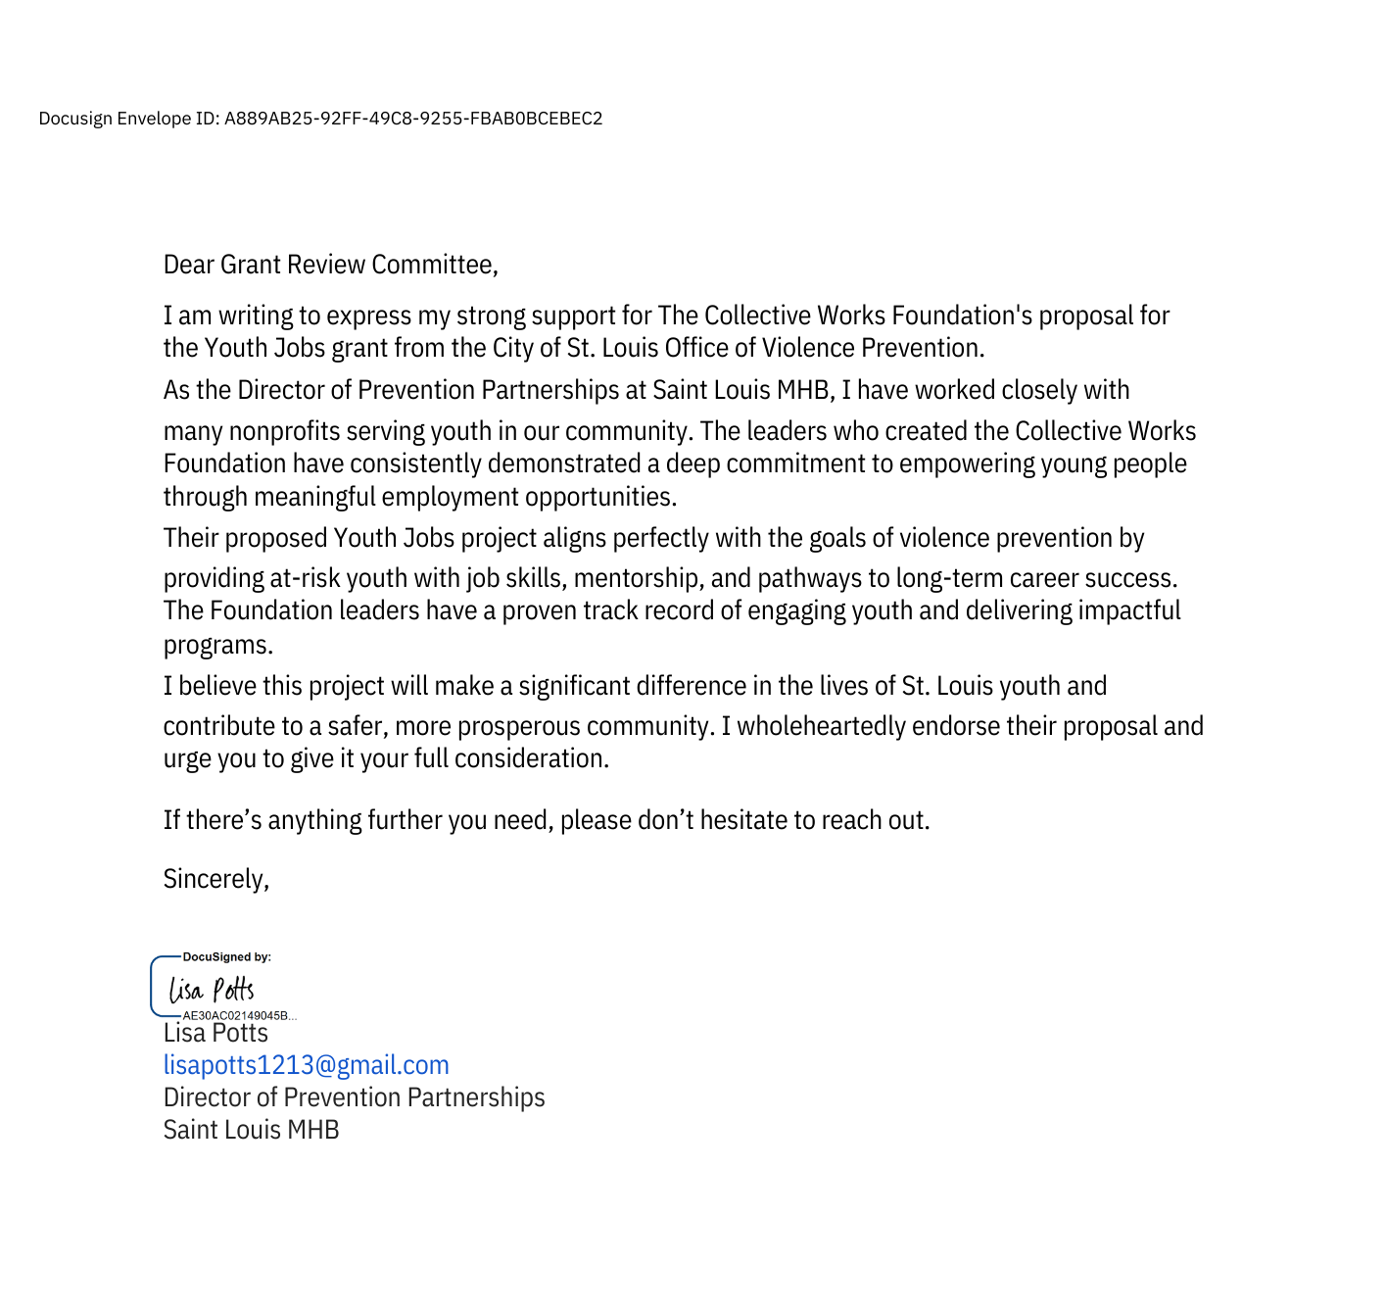

Attachment 1 — Letter of Reference #2
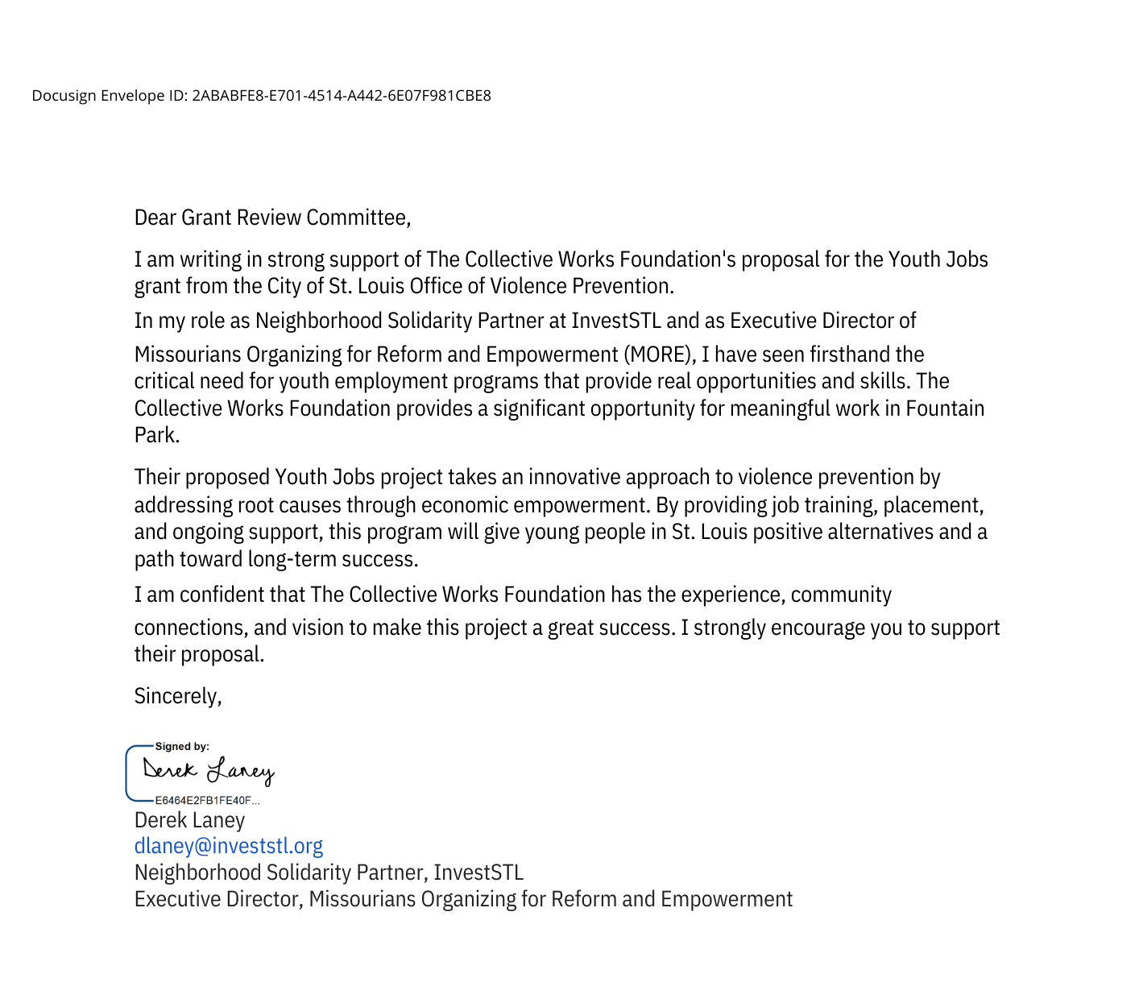

Attachment 1 — Letter of Reference #3


Attachment 2 — Resumes/Qualifications
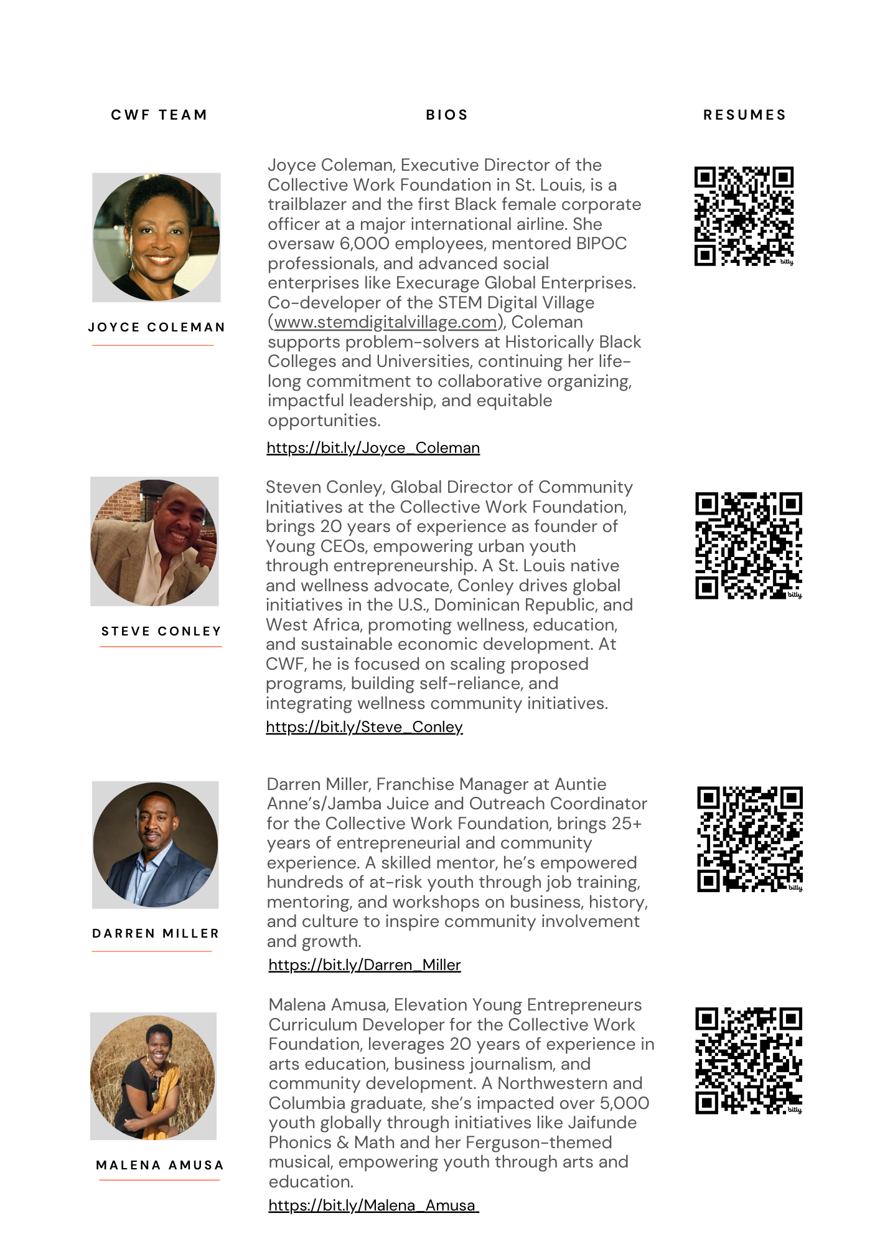

Attachment 3 — Organizational Chart

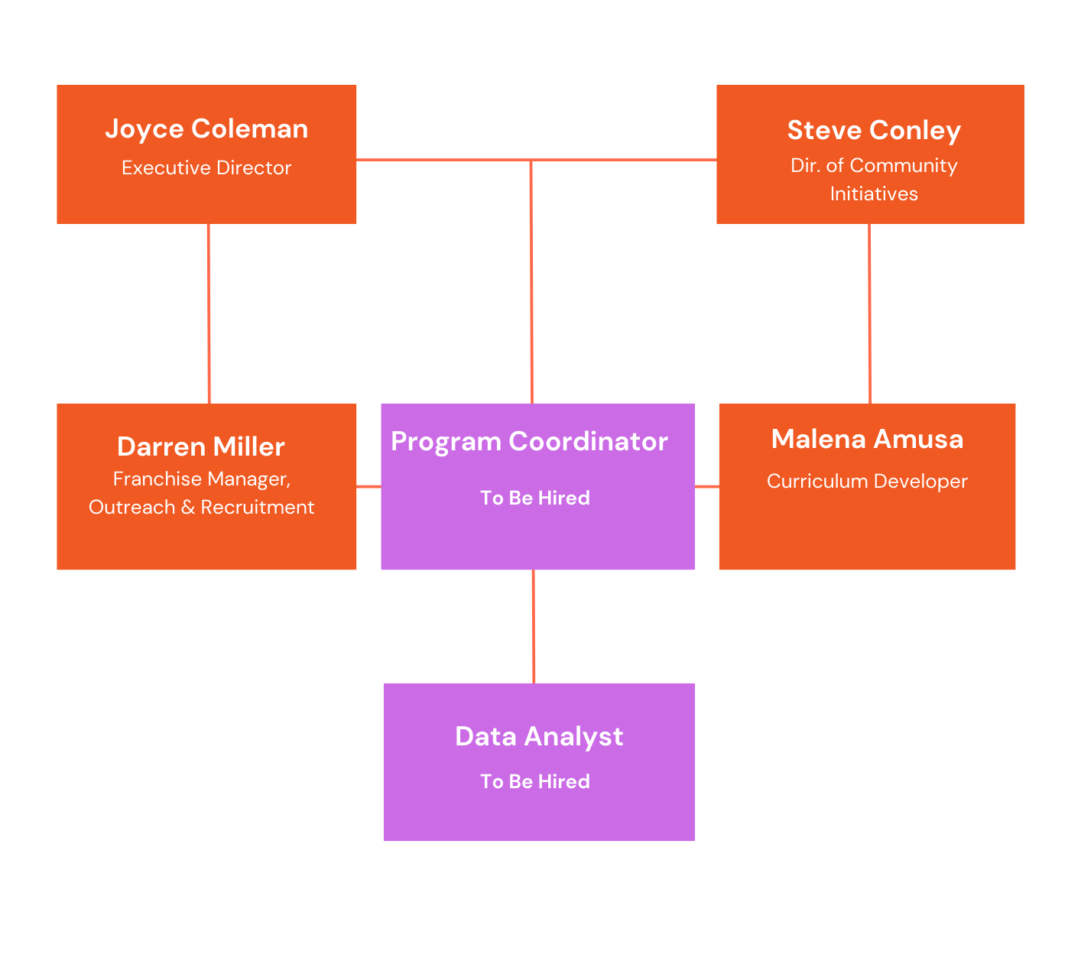

Attachment 4 — Elevation Young Entrepreneurs (EYE) Curriculum Snapshot (1/5)
The Elevation Youth Entrepreneurs (EYE) program provides participants with 360-480 hours of hands-on, on-the-job training led by franchise managers and guest business leaders over the course of three months. Each day includes 35 minutes of mentoring and coaching, supplemented by 5 hours of interactive learning every Saturday, totaling 95 hours of curriculum enrichment. By combining inquiry-based mentorship with culturally responsive, asset-based strategies, EYE equips participants with practical experience and transformative training opportunities.
Below is a pie chart illustrating the distribution of training hours in the EYE program.
EYE Program Curriculum By-The-Hours

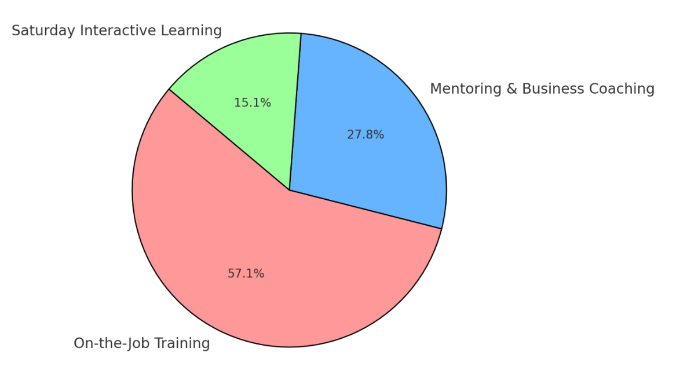

Attachment 4 — Elevation Young Entrepreneurs (EYE) Curriculum Snapshot (2/5)

Weekly Schedule
Day | Time | Activity/Topic | Leader
Monday - Friday | 9:30am - 3:30pm (Part-Time)  11am - 7pm (Full-Time) | Franchise On-the-Job Training | Franchise Managers as Mentors
Saturday | 9:30am - 2:30pm | Employee-Preneur Personal Development Workshop | STL Business Leaders and Educators

Core Objectives (as "I" Statements)
Mon-Fri
- I can identify my personal strengths and challenges and leverage them toward improving my communication and teamwork skills each day.
- I actively participate in solving real business challenges, implementing operational strategies and working well with my team.
- I actively set personal goals each morning and reflect on my progress at the end of the day.
- I receive daily feedback from my franchise manager on how I’m applying my skills and where I can improve.
Saturday Workshop
- I can confidently build my financial literacy, goal-setting abilities, and learn to present myself professionally.

Attachment 4 — Elevation Young Entrepreneurs (EYE) Curriculum Snapshot (3/5)

Franchise Managers’ Sample Lesson Plan & Itinerary for Monday - Friday
Week 4_Module 2
Objective: Empower participants to explore and apply operational and financial principles relevant to their roles, while building self-confidence and honing interpersonal and professional communication skills.
- Morning Briefing (5 min):
  - Daily Goals: Collaboratively set business and communication targets (e.g., improving inventory tracking or enhancing customer inquiry processes).
  - Team-Building Exercise: Share the Highlight—participants share significant challenges or successes, enhancing peer learning and strategic thinking.
- Interactive Scenarios & Training (10 min): Franchise managers present operational scenarios (e.g., handling complaints, managing shortages). Participants practice responses, with feedback on professionalism, clarity, and confidence-building techniques.
- Financial Literacy Mini-Lesson (7 min): Participants learn inventory management strategies to support budgeting and sustainability, tracking items to reinforce financial principles.
- Afternoon Reflection (5 min): Participants review their goals, complete a self-reflection sheet, and identify strengths, improvements, and strategies for effectiveness.
- End-of-Week Assessment (5 min)
  - Feedback Circle: Franchise managers provide focused feedback, assessing participants' application of operational, financial, and strategic concepts alongside their communication skills.
  - Reflection and Social Media Sharing: Participants consider how the integration of these skills supports successful franchise operations and entrepreneurship, and share their reflections in a social media video.

Attachment 4 — Elevation Young Entrepreneurs (EYE) Curriculum Snapshot (4/5)

Employee-Preneur Saturday Workshop Sample Itinerary
Week 4_Module 2
Objective: Equip participants with essential financial literacy skills and effective communication techniques that enhance their confidence and future entrepreneurial endeavors.
9:30 am — 10:00 am: Introduction & Interaction: Financial Goals Sharing
- Each participant introduces themselves and shares a financial goal related to their work at the franchise (e.g., saving for college or budgeting for personal expenses).
10:00 am — 11:30 am: Workshop 1: Understanding Financial Basics
- Key Principles of Business Banking. Participants learn about budgeting, saving, credit, and the importance of financial planning.
- Activity: Budgeting Project. Participants work in small groups to create a budget for a hypothetical business venture, incorporating expected expenses and potential revenue. Groups present their budgets, discussing financial decisions and strategies.
11:30 am — 12:00 pm: Guest Speaker: Local Banker on Financial Literacy in Business
- Q&A session: Participants ask questions about budgeting, saving strategies, and preparing for future financial needs.
12:00 pm — 12:30 pm: Lunch Break & Informal Networking

12:30 pm — 2:30 pm: Workshop 2: Collective Practice — Crafting Your Financial Presentation
- Participants work in groups to create a presentation outlining their financial goals, budgeting strategies, and what they’ve learned about business banking.
- Participants are encouraged to incorporate storytelling, visuals, and key financial insights from the morning session.

Attachment 4 — Elevation Young Entrepreneurs (EYE) Curriculum Snapshot (5/5)
1:30 pm — 2:00 pm: Presentation & Feedback
- Participants share their financial presentations to small groups, with peers and mentors providing constructive feedback on strengths and areas for improvement.
- Focus on clarity, engagement, and the application of financial concepts learned.
2:00 pm — 2:15 pm: Assessment and Feedback
- Each participant receives feedback on their presentation clarity and financial understanding.
- Mentors assess participants’ growth in financial literacy and communication skills, noting progress since the start of the week.

2:15 pm — 2:30 pm: End-of-Workshop Reflection
- Participants reflect on key learning points from the day and set one actionable goal for improving their financial literacy or communication skills.
- Participants share their experience through social media posts.

Expected Outcomes for the Week
- EYE participants create a tangible presentation reflecting their financial and business goals.
- Participants develop a solid understanding of financial principles, benefiting their roles at the franchise and preparing them for future financial responsibilities.
- Improved thinking and communication skills will aid participants in defining and communicating their personal mission and values.
- Hands-on budgeting projects build awareness of how effective financial management impacts business operations and personal success.
- Regular goal-setting and reflections enhance participants’ self-awareness and personal accountability in both financial and business contexts.

Attachment 4 — Memorandum of Agreement (1/2)
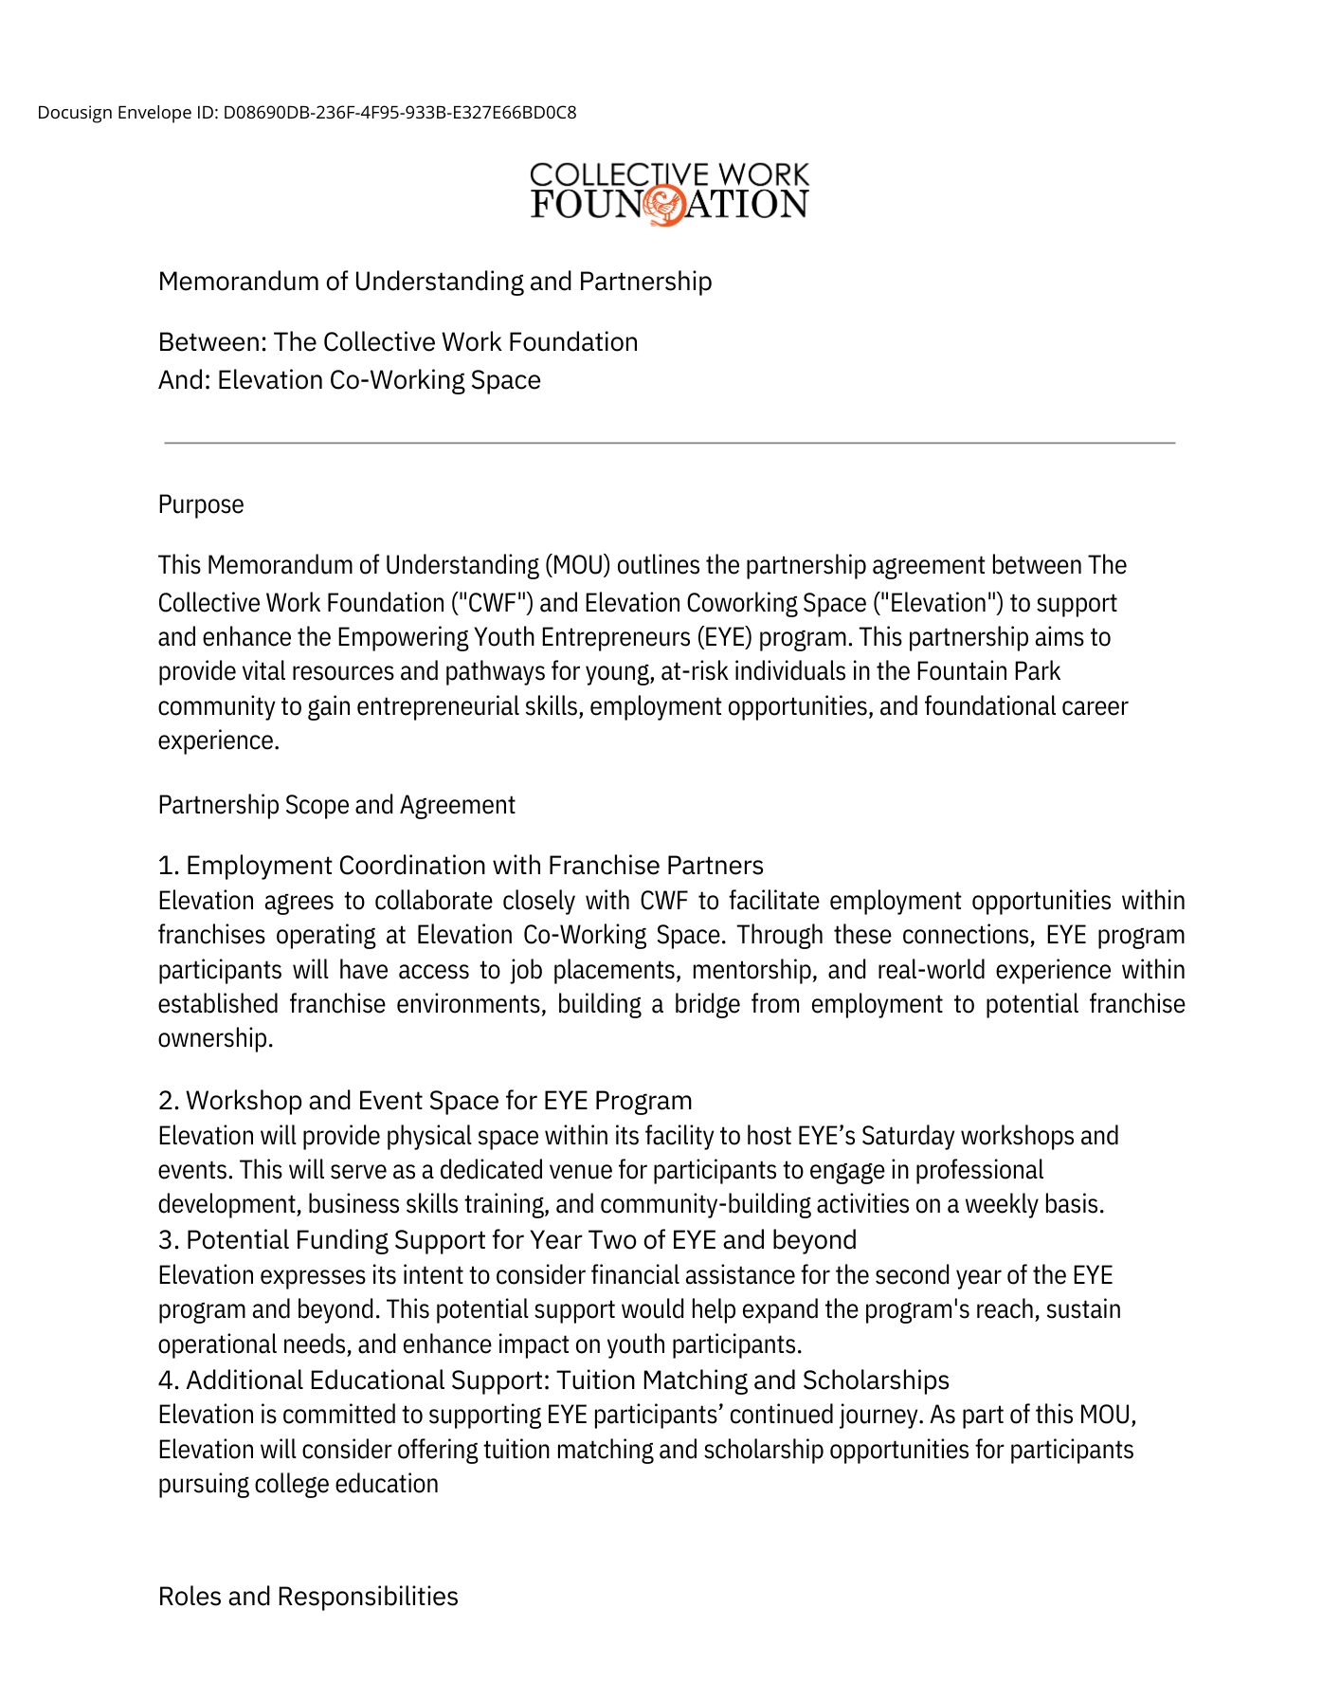
Attachment 5 — Memorandum of Agreement (2/2)
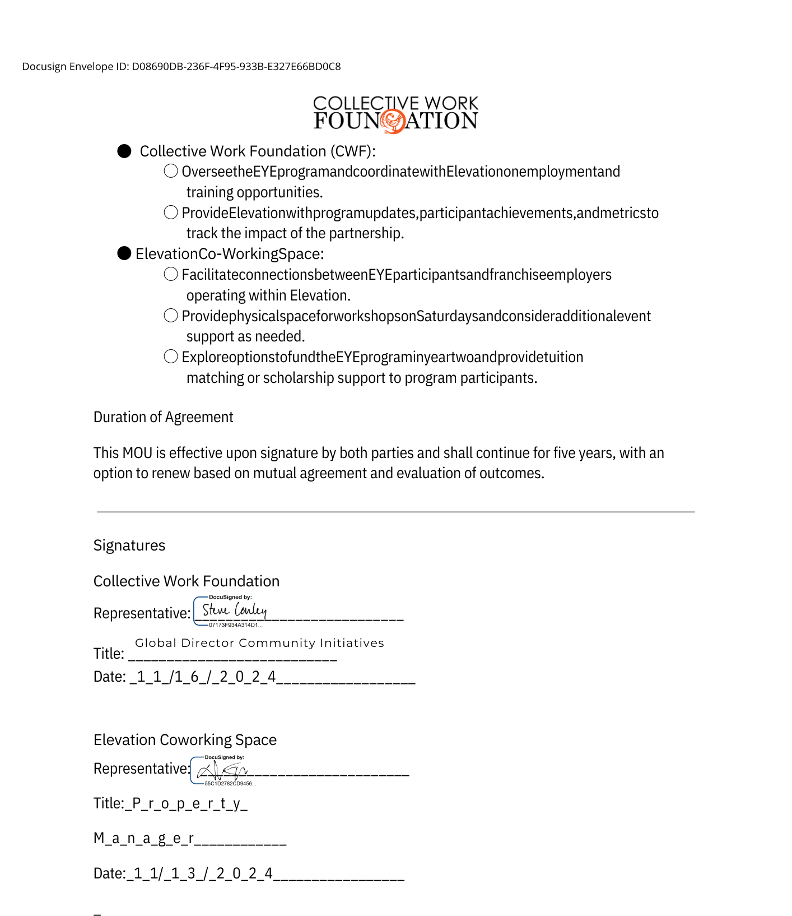

Attachment 6 — Budget for Year 1 of the EYE Program
Item | Cost | Description
EYE Personnel
Program Director | $22, 880 | Part-Time role to oversee advancement of partnerships and program implementation, program tracking & budget oversight, monitoring & evaluation at $22_hr_20 hrs/week.
Program Coordinator & Saturday Workshop Host | $45,760 | Salary for a Full-Time Program Coordinator to oversee day-to-day operations and host Saturday workshops, at $22/hr _ 40 hrs/week.
Data Analyst | $17,160 | Part Time Data Analyst to assist with collecting, tracking and reporting inputs, outputs, and outcomes, at $22/hr_15 hrs/week.
Outreach & Recruitment Coordinator | $11, 440 | Part-Time role to oversee and ensure participant conversion on strategic recruitment activities, at $22/hr_10 hrs/week.
Curriculum Development | $4,500 | Part-Time role to complete the development and refining of the EYE curriculum, including materials and resources, $22/hr_10 hrs/week.
Training & Development
At-Risk Youth Intervention Training | $5,000 | *This cost may change depending on the potential of this training to be offered through the Public Safety Department and OVP.
Operational Costs
Space Rental at Elevation Workspace | $0 | Cost for renting meeting rooms at Elevation Coworking for program activities and workshops, thanks to the generosity of our collaborating program partner.
Program Supplies | $150 | General office supplies, including paper, pens, and other materials needed for program operations.
Total Budget | $106,890
*CWF has not included health benefits as we do not plan to offer them at this time. To ensure our staff has access to health care, we will refer all staff to public healthcare options, where they can select and purchase a plan if needed.
Attachment 7 — Letter Concerning Financial Status

City St. Louis Office of Violence Prevention
2125 Bissell Street
St. Louis, MO 63107
Dear Grant Review Committee,
Re: Request for Proposal for Youth Jobs - Financial Documentation Explanation
I am writing on behalf of the Collective Work Foundation regarding our application for the Request for Proposal for Youth Jobs. We understand that a Federal 990 form, independent audit, or certified financial statement is typically required. However, as this is our first year actively pursuing grant opportunities, we are unable to provide these documents at this time.
Our organization, established in March 2017 and inspired by the 3rd Principle of Kwanzaa (Ujima: "collective work and responsibility"), has operated entirely on a volunteer basis with no financial transactions to date. As a result, we have not yet engaged in formal financial reporting or audits.
To provide additional context:
- Since inception, our work has focused on strategic meetings and planning.
- We plan to establish financial systems to support formal reporting as we begin receiving funds.
- We are committed to financial transparency and accountability as we grow.
We greatly appreciate your understanding of our situation and hope this explanation serves in lieu of the required documents. We are excited about the opportunity to provide job training to high-risk youth aged 15–24 and look forward to contributing to this important initiative.
Thank you for your consideration.
Sincerely,

Joyce Coleman
Executive Director, CWF
joycecoleman@charter.net
(314) 267 - 5549

Verification of License Taxes (1 of 2)

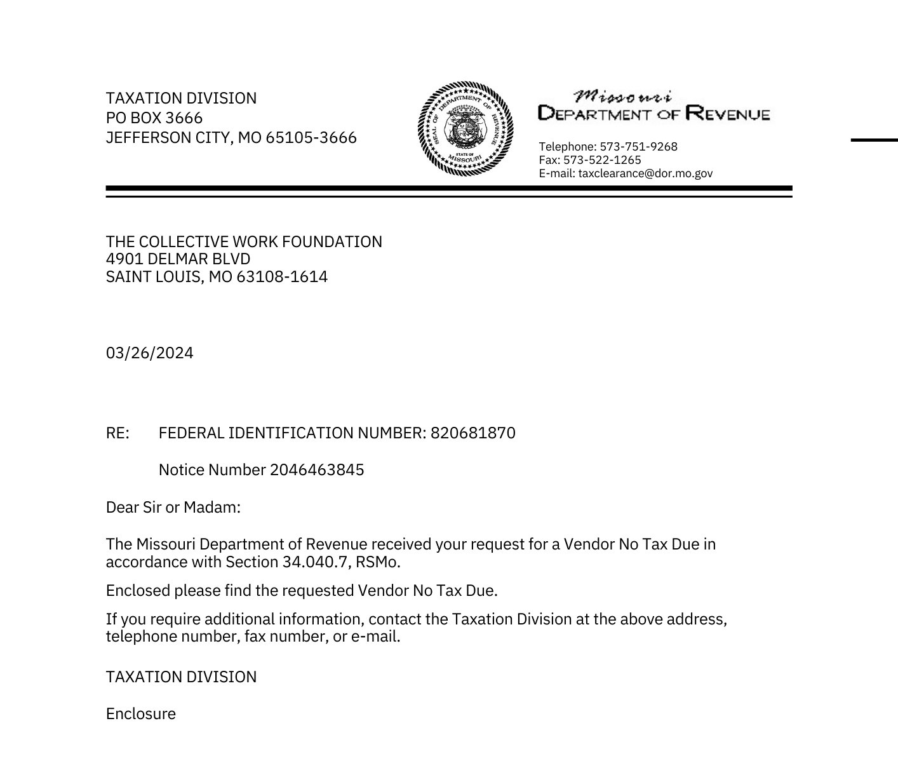

Verification of License Taxes (1 of 2)
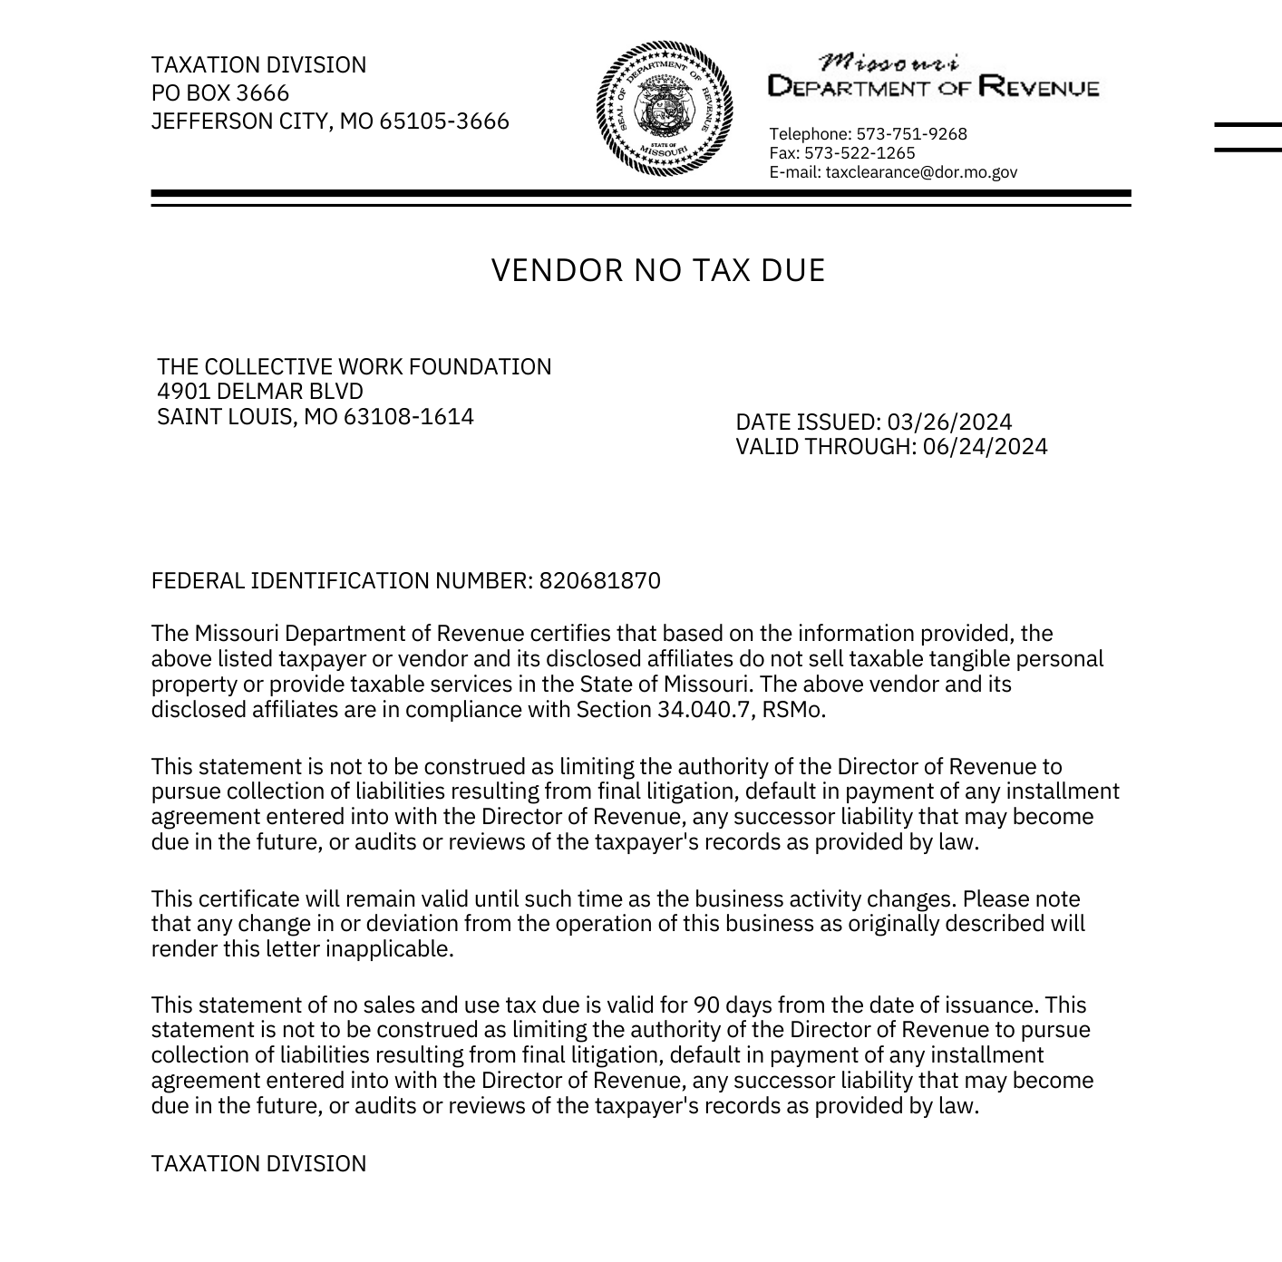

Minority & Women Business Enterprises
The Collective Work Foundation is not currently certified as a Minority or Women Business Enterprise (M/WBE). Recognizing the value of M/WBE certification in advancing equitable economic opportunities, we might explore the steps to achieve this certification in the future.

